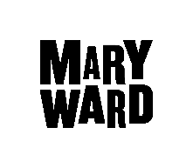
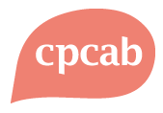
THE PROFESSIONAL DIPLOMA
IN
INTEGRATIVE COUNSELLING
(BACP accredited course)

The Diploma is awarded by CPCAB

Qualification gained is Diploma in Therapeutic Counselling TC L4

September 2022 - July 2024

Yr 1 Tuesdays 10.00-17.15; Yr 2 Fridays 10.00 -18.00

Fees for the two year course are: Full Fee £6400; concession £4670.
Fees include tuition, supervision, weekend workshop, and 10 sessions of therapy in Year 1(max £40 per session).
Student Loan Available.

MARY WARD

The friendly place to learn

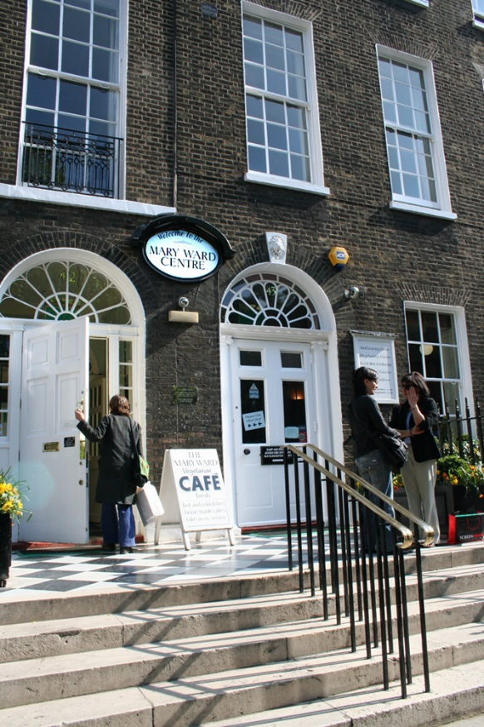
With over a hundred years' experience of developing and delivering education programmes for adults, the Mary Ward Centre remains one of London's major centres for adult learning.
We have a long tradition of offering courses in personal development and we offer a spectrum of courses aimed at enabling students to acquire and live with greater confidence. Our counselling courses lie at the heart of our Health and Social Care programme and are offered at four different levels - from

Level 2, an introduction to the basic method and practice of counselling, through to Level 3 Diploma in Counselling Skills, Level 4 Professional Diploma in Integrative Counselling and finally with the Level 6 Certificate in Therapeutic Counselling Supervision.

AIMS OF THE COURSE

The Diploma in Counselling provides professional counselling training in the public sector. On successful completion of the course students will be able to practice as counsellors within an agency. The course also examines the wider context of counselling. It looks at the meaning of an ethical professional stance and its implications, and explores students' attitudes to people who may be different from themselves.

CONTENT__________________________________________

The course content includes:
- Developmental Psychology which includes: Freud and his legacy, Bowlby, Winnicott, Stern and the new research in neuroscience
- Theory and implications of transference and counter transference
- Personality types
- Legal and ethical issues in counselling
- Psychology across the life span
- Intercultural communication and the political dimension
- Mental Health Disorders
- The Transpersonal Dimension

Skills developed include:
- contracting skills
- building the working alliance
- the capacity to self-monitor
- the use of interpretations
- basic research skills
- creative techniques for working with unconscious processes
- advanced processing skills
- working with endings

OBJECTIVES

By the end of this course the student will:
- be able to work competently as a counsellor in an agency setting.
- have developed strategies for working across barriers of culture, class, sexual orientation and other differences.
- be able to maintain a counselling relationship through all stages, from initial contact to completing the counselling contract.
- be committed to maintaining ethical standards of professional practice.
- know their limitations, and understand how to make appropriate referrals.
- understand the importance of supervision, and use it constructively.
- have developed respectful attitudes to others.
- have a sound foundation for working towards individual Accreditation as a counsellor with the BACP.

CORE MODEL

The core model is integrative, based primarily on the work of Clarkson, as described in The Therapeutic Relationship. It acknowledges the central importance of the relationship between counsellor and client, identifying five aspects of it:-

- the working alliance
- the reparative relationship
- the transference/counter transference relationship
- the I - Thou or person-to-person relationship
- the transpersonal relationship.

These five themes will run through every aspect of the course.

PHILOSOPHY OF THE COURSE

The course will integrate humanistic, analytic and transpersonal perspectives. We shall offer a mixture of theory, personal development and skills practice, which will encourage students to reflect widely on every aspect of their lives and identities - physical, emotional, social, mental and spiritual.

The professional life of a counsellor is a continually developing dance between self, other and the wider world. Issues arise in relation to the counsellor's own experience, in clients' material, in supervision and in the counsellor's own therapy. The counsellor's understanding of him or herself in relation to self and others - clients, family, community, society and the wider world - needs to be constantly growing and changing. This core training is an initiation into this dance.

Inclusiveness is a core value of the approach. The theme of relating to the Other will be central. Special attention will be paid to the processes which ensue when the Other is of a different ethnicity, class, sexual orientation, culture, or is impaired. We aim to be innovative and thoughtful in our approach and believe that the best ways of learning involve the students' active participation – we will use learner-centred methods wherever possible.

COMMITMENT

The Diploma runs over two academic years from September 2021 to July 2023. Class meetings will be for 6 hours per week, over 36 weeks for each academic year, and in addition there will be one weekend per year. There is a requirement that students reach a minimum of 80% attendance over each year.

Students will be expected to be working with clients on placement, under supervision, from the second term of the first year. These placements will be organised by students, although tutors will offer help and guidance. Students will be required to have had a minimum of 10 hours experience as a client in individual counselling or therapy by the end of the first term and will continue in weekly therapy throughout the course.

Students will also be required to spend additional time reading, thinking and producing written work. There will be tutorials for students outside the regular class meetings.

PLEASE NOTE. THE FIRST MEETING OF THE COURSE IS THE WEEKEND OF 24th & 25th SEPTEMBER 2022

ASSESSMENT
Supervision
Trainees will work in small supervision groups at the Mary Ward Centre from the second term of the course on a fortnightly basis.
Theory and Skills

Theory and skills assessments are based on specific learning outcomes and will be evidence -based. Students will be expected to produce a portfolio of evidence of their learning by the end of the second year. There will be an external assessment involving skills and theory which includes a written paper taken under exam conditions.

ENTRY REQUIREMENTS

Candidates should have:

- completed CPCAB’s Diploma in Counselling Skills and Diploma in Counselling Studies , or equivalent ie 180 hours of formal counselling training (student to provide a copy of the Certificate).

- a recommendation from a previous Counselling tutor that the student is suitable to undertake such a course.

- where applicable, a supportive statement from the student's counsellor or mental health professional.

- sufficient and appropriate personal resources to embark on a demanding professional training.

- GCSE in English Language, grade A – C (or equivalent , plus fluency in spoken English.

The Centre can offer limited support to students who have difficulty with written English. If this is an area of difficulty for you, discuss this with us at your interview. We wish to encourage people who have potential counselling abilities to find ways round any academic difficulties they may have.

Prospective candidates must complete an application form and attend an interview.

We do give priority to internal applicants who have completed the Diploma in Counselling Skills with us. This means that we will only be able to consider external applicants once we have interviewed all the internal applicants who have applied for a place on the Level 4 Diploma. Given we have only a limited number of spaces on the Level 4 course, there is every chance that we will fill the available spaces on the course through this process. You are still very welcome to apply for a place with us but please do be aware that the chances of us having available spaces are not that high. We will know in July if we do have spaces available for external applicants and we will contact you then to invite you to an interview if that is the case.

ADMISSION PROCEDURE

Application Forms

Completed application forms should be returned to the Mary Ward Centre as soon as possible. There will be interviews in May, June and July.

This course is often oversubscribed. Once all the available places have been offered, we will no longer be able to accept applications. You are therefore strongly advised to apply as early as possible in order to avoid disappointment.

Closing date 1st July 2021

For further enquiries please contact

Cecilia Jarvis at counselling@marywardcentre.ac.uk

Mary Ward Centre
42 Queen Square, London WC1N 3AQ
(main building)

Tel: 0207 269 6022
www.marywardcentre.ac.uk

