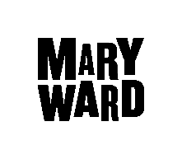

Level 2: Introduction to Counselling

Level 3: Diploma in Counselling Skills (ABC)

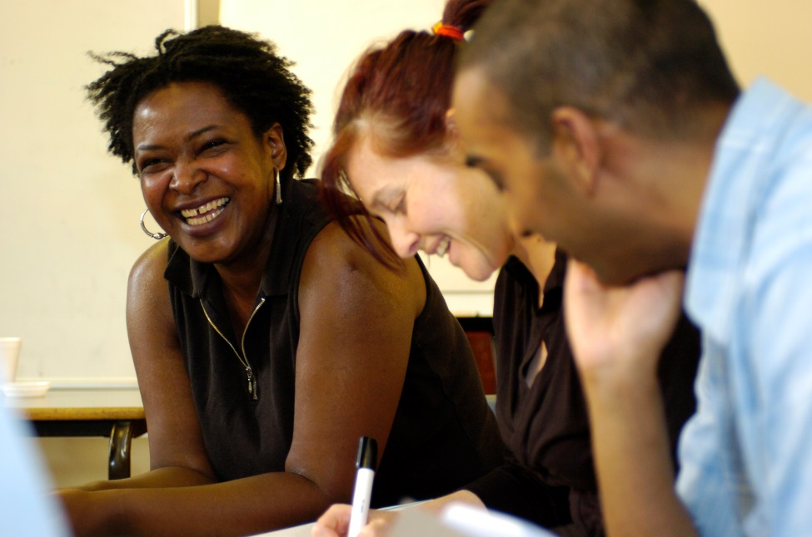

Level 2 Introduction to Counselling: 22/09/2022 – 27/10/2022
This is a six week course of 30 hours. Anyone may apply.

Daytime courses 10.00 – 3.30pm | £200 Full fee  £70 Concessionary fee
Evening courses 6.00-10.00pm
Additional weekend date:

Level 3 Diploma in Counselling Skills: 10/11/2022 – 27/07/2023
This is a thirty week course consisting of 150 hours of training. There is a compulsory weekend for the course. The evening course has three additional Saturday workshops. Applicants must have completed a level 2 Counselling course or have equivalent experience in order to be eligible for this course. Applicants must also have a level 2 in English (grades A-C) or the equivalent.

Daytime courses  10.00 – 3.30pm  Additional weekend dates:11th & 12th March 2023, 10-5pm | Fees: £2, 225
Evening courses
6.00-10.00pm
Additional weekend dates: 26th November 2022,11th February 2023, 11th & 12th March 2023 & 17th June 2023, 10:00 - 5pm

Note: If you opt to apply for the Advanced Learner Loan for this course,
a deposit of £100 is required to secure your place.

How to apply
If you want to apply for one or both of these courses you need to fill in the enclosed application form. Return the completed application form to us at counselling@marywardcentre.ac.uk as soon as possible.
Interviews will be held, possibly online, during July and September, but in some cases may be held earlier. The final deadline for applications is on 31 August.

Late applications for the Diploma in Counselling Skills level 3.
Late applications may be accepted if received by 1st October 2022 and will be considered only if there are still places available.
Please note: often these courses are oversubscribed by 1st September. It is in your interests to get the application in as early as possible.

Interviews
For both courses there will be a group interview followed by a short individual interview with one of the counselling tutors. You will need to be available for about four hours on the day of the interview from about 10.30 to 2.30.

If you are applying for both the Introduction and the level 3 course you will be interviewed only once.

Transition from level 2 Introduction to Counselling to level 3 Diploma in Counselling Skills
Transition is not automatic and we always have more applicants than we have places. To be offered a place on the level 3 Diploma in Counselling Skills course, you will need to have successfully completed an Introduction to Counselling course either at the Mary Ward Centre or another college. In addition you will need:

- A recommendation from your level 2 tutor which confirms that you have the psychological awareness and personal stability to commence further training.
- Good spoken English
- Level 2 in English language (grades A-C) or the equivalent.
- A copy of your level 2 certificate of attendance/completion.

Level 3 Diploma in Counselling Skills
If you are offered a place on this course, the first eight weeks of the course are a probationary period, during which, we will assess your suitability for the course. At the end of this time you will have a tutorial to discuss your progress and continuation on the course.

If you have any queries you can email us at counselling@marywardcentre.ac.uk

Good luck with your application and we look forward to reading it.
Sue Healey.

Mary Ward Centre, 42 Queen Square, London WC1N 3AQ (main building)
www.marywardcentre.ac.uk / 0207 269 6022 / counselling@marywardcentre.ac.uk

LEVEL 2 INTRODUCTION TO COUNSELLING

General Information

This course is a general introduction to the methods and practices of counselling and the skills which form the basis of the counselling relationship, for use in personal or community situations. The course is based on experiential learning, discussion and skills practice. The course carries a certificate of attendance.

WHAT PREVIOUS KNOWLEDGE/EXPERIENCE /SKILLS ARE REQUIRED.

This practical course is for students who wish to expand their use of listening skills within their current work (paid or voluntary). It is also for students who are interested in finding out more about counselling. No previous knowledge is expected.

CRITERIA FOR SELECTION.

- capacity to work within a group
- psychological stability

START DATE; 22nd September 2022 for six weeks.

COURSE CONTENT

The course has theoretical input and practical work in pairs and triads.

The topics will include;
- what is counselling
- basic safety and trust whilst listening
- basic counselling skills of reflection and empathy
- understanding power dynamics within a counselling setting
- issues which arise form group discussion
- developing self awareness

MATERIALS FOR THE COURSE.

Writing materials.
Small writing book as a personal journal.

WHAT YOU SHOULD BE ABLE TO DO BY THE END OF THE COURSE.

- listen more attentively
- communicate using the basic reflective skills more effectively
- begin observing yourself as a listener
- begin reflecting on what’s happening inside yourself.
- apply for the MWC level 3 course

THE TEACHING AND LEARNING METHODS WE USE ON THE COURSE.

- informal discussion
- practical skills work through role play and pair work
- students’ self-reflection on their own learning process.

HOW WE ASSESS YOUR PROGRESS ON THE COURSE.

At the start:
We invite students to make a self-assessment of their skills and to reflect on why they are drawn to the course.

On the course:
Students receive feedback from the tutor and their peers about skills development. Classroom observation to see how the student is participating in the group.

At the end:
The student writes a learning statement which is assessed by the tutor. Brief skills work assessment.

EXTRA STUDY OR PRACTICE EXPECTED.

Write a learning journal
Apply skills outside the classroom where appropriate.
Optional reading.

WHAT YOU CAN DO NEXT AFTER THE COURSE.

A level 3 Diploma in Counselling Skills course.

COST

The fees for 2022-2023: £200, concession £70

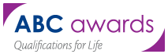
LEVEL 3 DIPLOMA IN COUNSELLING SKILLS (ABC)

General Information

This course includes theory, practical skills, personal development, a weekend component (for which attendance is essential). There is an overall attendance requirement of 80%. The course is validated by the ABC awarding body. Successful completion of the course is one of the entry requirements for a level 4 Diploma in Counselling.

CRITERIA FOR SELECTION.

- psychological stability
- the beginnings of the capacity to reflect on oneself and to begin to see patterns of relating
- the ability to work within a group
- completed 30 hours of formal counselling training or had equivalent experience.

START DATE: 10th November 2022

COURSE CONTENT

Skills:
- recap on basic listening skills
- challenge skills, process monitoring, advanced accurate empathy, how to use
- questions, how to make a counselling contract
- how to open and close a counselling skills session
- giving and receiving feedback

Theory:
- the key concepts of person centred, psychodynamic and CBT approaches to counselling
- an ethical framework for counselling
- counselling and diversity
- the context for using counselling skills
- theory of personal development

Personal development:
- students will participate in a weekly personal development group.

MATERIALS FOR THE COURSE

Some basic counselling texts.
Writing materials for class notes and a notebook for use as a personal journal.

WHAT YOU SHOULD BE ABLE TO DO AT THE END OF THE COURSE.

- Demonstrate an increased awareness of yourself and how you affect others.
- Have thought about issues of difference and disadvantage and your own responses to these issues.
- Have developed or strengthened your commitment to anti-oppressive practice in the use of counselling skills.
- Name and use appropriately the skills introduced.
- Initiate, maintain and complete an interaction using counselling skills.
- Have an understanding of the Person centred, psychodynamic and CBT models of counselling.
- Have an understanding of and commitment to the BACP framework for good practice in counselling and psychotherapy

THE TEACHING AND LEARNING METHODS WE USE ON THE COURSE.

Tutor presentations and class discussions with some student presentations. Structured pair work with role plays and practical sessions. An experiential personal development group facilitated by the tutor.

HOW WE ASSESS YOUR PROGRESS ON THE COURSE.

The first eight weeks are a probationary period, during which, we will assess your suitability for the course. At the end of this time you will have an individual tutorial to discuss your progress and continuation on the course.
There will be ongoing tutor and peer feedback about skills work. You will also self assess in class and through journal writing.

There are five learning units. Students will produce a portfolio of evidence to cover the five learning units. The portfolio of work and evidence is a substantial piece of work

Skills will be assessed formally in class by the tutors.

WHAT EXTRA STUDY/PRACTICE WE EXPECT YOU TO DO OUTSIDE CLASS.

- private study
- use listening skills in an appropriate environment if possible.

WHAT CAN YOU DO AFTER THIS COURSE.

A level 4 Diploma course if you wish to train as a counsellor. The centre offers The Professional Diploma in Integrative Counselling (a BACP accredited course) validated by the CPCAB awarding body

COST

The fees for 2022-2023: £2225. (Student loan available)

Note, once you have accepted a place, fees are not refundable.

CAN I SPREAD THE COST OF THE FEES?

You can pay the fees either as a lump sum, by instalments (50/50) paid in full by 1 December or by student loan.

HOW DO I APPLY FOR A STUDENT LOAN?

The loan application is done online with student finance england on the gov.uk website

WHAT DOCUMENTS DO I NEED TO APPLY FOR A LOAN?

- National Insurance number
- Valid UK passport or
- Valid passport/ birth/ adoption certificate (documents may need to be posted to the Student loans office)
HOW DO I SECURE MY PLACE IF I AM WAITING FOR A DECISION ON MY LOAN APPLICATION?

You must enrol with a deposit of £100.

WILL I GET MY DEPOSIT BACK?

If you decide to deduct the deposit from the amount of loan you are borrowing then you will not receive the deposit back.

If you borrow the full amount, then the deposit is returned to you at the end of the academic year, provided the loan is and remains approved and you do not withdraw from the course or cancel the loan.

