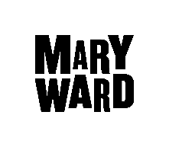

Level 3

Certificate in Community Interpreting
A course for you to put to work your ability to speak English and another language and to gain a nationally recognized Level 3 Ascentis Certificate in Community Interpreting.

Venue: All courses in 2022-23 will be delivered in person, subject to any restrictions arising from the Coronavirus.
309L | 20 Sep-06 Dec 2022  Tuesday, 10:30-17:30  Closing date for application: 06 Sep 2022 | 12 meetings
310L | 17 Jan- 28 Mar 2023  Tuesday, 10:30-17:30  Closing date for application: 13 Dec 2022 | 11 meetings
311L | 25 Apr-11 Jul 2023  Tuesday, 10:30-17:30  Closing date for application: 11 Apr 2023 | 12  meetings
312L | 24 Sep-10 Dec 2022  Saturday, 10:00-17:00  Closing date for application: 10 Sep 2021 | 12 meetings
313L | 21 Jan-01 Apr 2023  Saturday& Sunday 10:00-17:00  Closing date for application: 15 Dec 2021 | 12 meetings
314L | 06 May-22 Jul 2023  Saturday& Sunday 10:00-17:00  Closing date for application: 13 Apr 2023 | 12 meetings
Please note, recruitment to the course occurs on an on-going basis so we cannot guarantee that there will be spaces left for people who apply close to the deadline for the course.
The course is for people who would like to develop their interpreting skills to train as interpreters and gain employment.

The course covers 7 units and offers participants the chance to gain 16 credits with Ascentis at level 3. You must gain all 16 credits to pass the course.

In order to be considered for the course it is essential that you
- Are fluent in English (minimum level 2 in all skills, CAE, C1 CEF)
- Are fluent in another language spoken in London
- Have experience of acting as an interpreter in public services in the UK. Some of this could be with family, friends or community members on a paid or unpaid basis, though must include experience of interpreting for people not previously known to you.
- Attend a minimum of 80% of the course – including the entire first half of the course and the final meeting.
You will not be eligible to have your coursework assessed if you do not fulfil this requirement.
The course will focus on………
- Interpreting skills
- The role of the interpreter and the issues this raises
- Public Service knowledge e.g. Education, Housing, Health, Benefits, Social Services, Immigration
- Issues of professionalism and analysis of own skills

How do I apply?
Application forms can be downloaded online at www.marywardcentre.ac.uk

Return your application form to:
interpreting@marywardcentre.ac.uk or

The Humanities Department, Mary Ward Centre
42 Queen Square, London WC1N 3AQ

How will I be contacted?
You will be contacted by email. Due to the large number of applicants, we cannot respond individually. Please provide an email address on your application form that you check regularly.

How much does the course cost?
Full fee £724. Once you accept a place on the course, the fees are non-refundable.

Can I apply for a student loan to pay for this course?
Yes you can apply for the Advanced Learner Loan, see the FAQ sheet for more details

How do I secure my place if I am waiting for my loan to be approved?
You must enrol with a deposit of £60.00 This will secure your place on the course so it is not offered to another applicant.

What if I am an overseas student?
Students from outside the European Economic Area who have been in the EEA for less than 3 years and are on a student, work or other temporary visa can still apply. But you will not be eligible for a student Loan.

HOW TO CONTACT US
Austin Hill
0207 269 6000/ 020 7269 6024
austin.hill@marywardcentre.ac.uk
Mary Ward Centre
42 Queen Square, London WC1N 3AQ (main building)
Courses 312L, 313L, 314L take place at this location
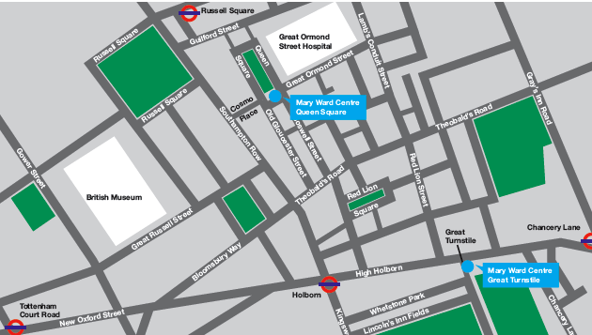
Mary Ward Centre at Blackfriars Settlement
1 Rushworth Street, London SE1 0RB
Courses 309L, 310L, 311L take place at this location
